Contents of Grant Proposal (written in Chinese or English):

- Background

Carbon fuel cells are promising and practical power generation technologies driven by direct utilization of abundant solid carbon reserves in the world [1]. Carbon fuel cells allow versatile solid carbon such as biomass (e.g. wood, coconut shell), coal, petroleum coke (e.g. residue from distillation unit in refinery plants), pyrolytic carbon (from natural gas), and municipal carbon wastes for conversion of chemical energy to electricity [2]. The electrical efficiency of power generation from carbon fuel cells can reach up to 100% compared with that of traditional coal-fired power plants, which are subject to thermodynamic limitation at 30-40% [3]. In addition, carbon fuel cells produce less noise, lower pollution, and pure carbon oxidation products (i.e. CO₂) for direct sequestration without expensive gas separation and energy intensive purification processes.

The promise of carbon fuel cells arises not only from diversity of available fuels and a promising operating efficiency but also a solid infrastructure for scale up, including transportation, storage, and processing of fuels. Due to their solid characteristics, carbons used in carbon fuel cell are easy to deliver and store, and the required infrastructure as well as processing of carbon have been well-established.

The research focus in fuel cell communities has started to shift fuels towards solid carbon in recent years. Solid carbon contains the maximum energy density (per unit volume), i.e. 20.0 kWh/L, compared to other kinds of fuels such as methane (4.2 kW h/L), hydrogen (2.4 kW h/L) and diesel (9.8 kW h/L). Solid carbon is projected as a primary fuel in the next two centuries owing to dwindling oil reserves. U.S. and China, who own the first and second largest coal reserves in the world, respectively, have extensive projects in exploring the utilization of carbon resources as shown in Table 1. In Taiwan, the government has strived to develop green energy technology and aim to generate 20 percent of the nation’s energy by 2025. To reach the goal, one of key factors is to exploit abundant solid carbon resources, i.e. biomass, such as agricultural and municipal carbon waste.

Whilst there is considerable potential and interest in carbon fuel cells as a power generation technology, the fundamental mechanisms underlying the operation of carbon fuel cells are still not well understood and the electrodes in conjunction with interconnect materials with matched mechanic properties and durability pose the barrier for commercialization. In the near and medium-term future, research and development of carbon fuel cell is still actively pursued in academia and industries, including: processing of solid carbon, electrode material, cell testing, modules and stacks, and applications of carbon fuel cell (Figure 1).

Form CM03 page_1_ of _13__ pages
Table 1 Literature survey of development on carbon fuel cell
Country | Center and Lab | Electrolytes | Development | Ref.
United States | Hawaii Natural Energy Institute, University of Hawaii at Manoa | Molten hydroxide electrolyte | - Aqueous-alkaline/carbonate carbon fuel cell  - Char production from biomass | [4]
United States | West Virginia University | Molten hydroxide electrolyte | - Evaluation of carbon materials for use in a direct carbon fuel cell | [5]
United States | Lawrence Livermore National Laboratory Livermore | Molten carbonate electrolyte | - Direct Conversion of Carbon Fuels in a Molten Carbonate fuel cell | [6]
United States | Stanford University;  Direct Carbon Technologies, LLC | Solid electrolyte membrane (YSZ) | - Fluidized bed direct carbon fuel cells  - Gasification-driven direct carbon fuel cells | [7-8]
United States | University of Utah;  Materials and Systems Research, Inc. | Solid electrolyte membrane (YSZ) | - Dry gasified coal SOFCs  - CO fueled solid oxide fuel cells | [9-10]
China | Tsinghua University | Solid electrolyte membrane (ScSZ) | - Catalytic gasification process  - Pyrolysis of hydrocarbons as carbon fuels | [11-12]
China | Tianjin University | Composite electrolyte; samarium doped ceria and a ternary carbonate | - Modelling and simulation of a single direct carbon fuel cell | [13-15]
China | Nanjing University of Technology | Solid electrolyte membrane (ScSZ) | - Carbon fuel cell integrated with in situ catalytic reverse Boudouard reaction | [16]
China | Shanghai Inorganic Energy Materials and Power Source Engineering Center | Solid electrolyte membrane (ScSZ) | - Direct carbon fuel cell with tubular SOFCs | [17]
China | Harbin Eng. University;  Tianjin University | Molten carbonate electrolyte | - Electrochemical oxidation activity of pretreated carbon | [18-19]
Europe | School of Chemistry,  University of St. Andrews, UK | Solid oxide and molten carbonate electrolyte | - Hybrid electrolyte carbon fuel cells  - Carbon fuels from pyrolysed biomass | [2, 3, 20-21]
Europe | ZAE Bayern, Garching, Germany | Solid electrolyte membrane (YSZ) | - Direct carbon conversion system with a non-porous anode | [22]
Europe | Delft University of Technology, Netherlands | Molten carbonate electrolyte | - Process intensification | [23]
Europe | Technical University of Denmark, Denmark | Solid oxide and molten carbonate electrolyte | - Electrode modification | [24-25]
Australia | School of Chemical Engineering,  University of Queensland | Molten carbonate electrolyte | - Carbon fuel evaluation  - Direct carbon fuel cells | [26-27]
Japan | Tokyo Institute of Technology | Solid electrolyte membrane | - Rechargeable carbon SOFCs by pyrolysis of hydrocarbons | [28-30]
Korea | Korea Institute of Energy Research (KIER), Hanbat National University | molten carbonate fuel cell | - Stack Design  - Catalytic effect of molten carbonate | [31-32]
Taiwan | Feng Chia University | Solid and molten electrolyte | - Electrode and cell Design  - Catalysis and performance evaluation

Form CM03 page_2_ of _13_ pages

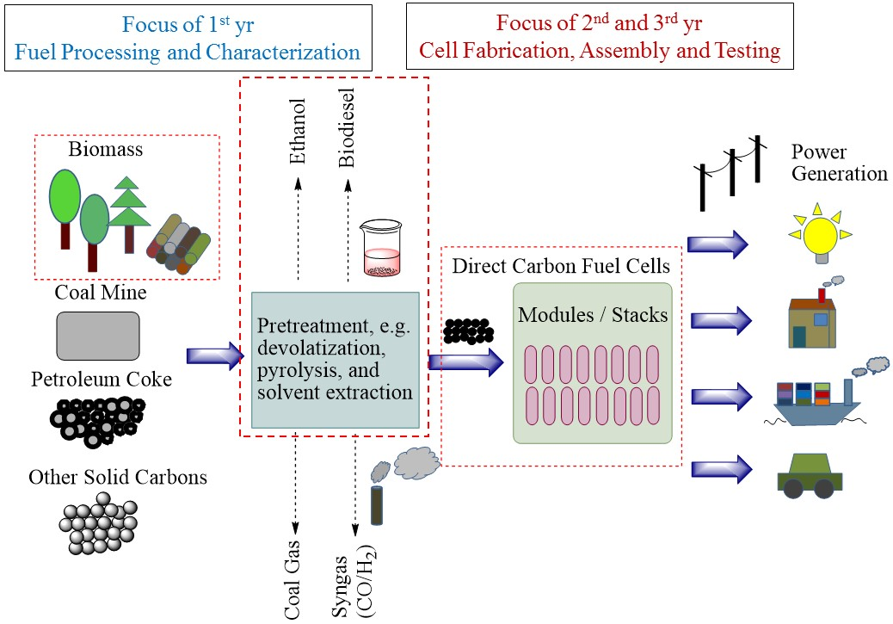

Figure 1. Schematic of Direct Carbon Fuel Cell System in a Sustainable Carbon Economy

- Methods, Procedures, and Progress

II-1 Research Principles and Methods

In Direct Carbon Fuel Cell (DCFC), carbon is fuel which is oxidised electrochemically by an oxidant on anode. The oxidant, which is conducted across electrolyte from cathode to anode, determines the oxidation mechanism and the type of carbon fuel cells. The type of DCFCs can be categorized by the electrolytes: molten salts, solid membranes, and combination of both. In molten salt based DCFC, carbonates (CO₃²⁻) or hydroxides (OH⁻) are major oxidant ions; in solid electrolyte based DCFCs, oxygen anion (O²⁻) is a major oxidant [7]. The anode and cathode reaction on these two kind of DCFCs are listed below, respectively:

Molten carbonate-based:
Anode: C + 2 CO₃²⁻ → 3 CO₂ + 4 e⁻ (1)
Cathode: O₂ + 2 CO₂ + 4 e⁻ → 2CO₃²⁻ (2)

Solid electrolyte-based:
Anode: C + 2 O²⁻ → CO₂ + 4 e⁻ (3)
Cathode: O₂ + 4 e⁻ → 2O²⁻ (4)

Overall: C + O₂ → CO₂ (5)

Form CM03 page_3_ of _13_ pages
Molten salts of alkali hydroxide were first used for the development of converting carbon to electricity successfully , while the cell performance degraded due to consumption of hydroxides via reaction with product, CO₂. The solid-electrolyte based DCFC (DC-SOFC) provides the advantage of assembly and process simplicity. The use of SOFCs for oxidation of carbon can be categorized by the way in contact of solid carbon as pictured in Figure 2. Although the non-contact mode in Fig 2 (a) received less attention for practical application, it simplifies reaction pathways and can serve as a basis for comparison.

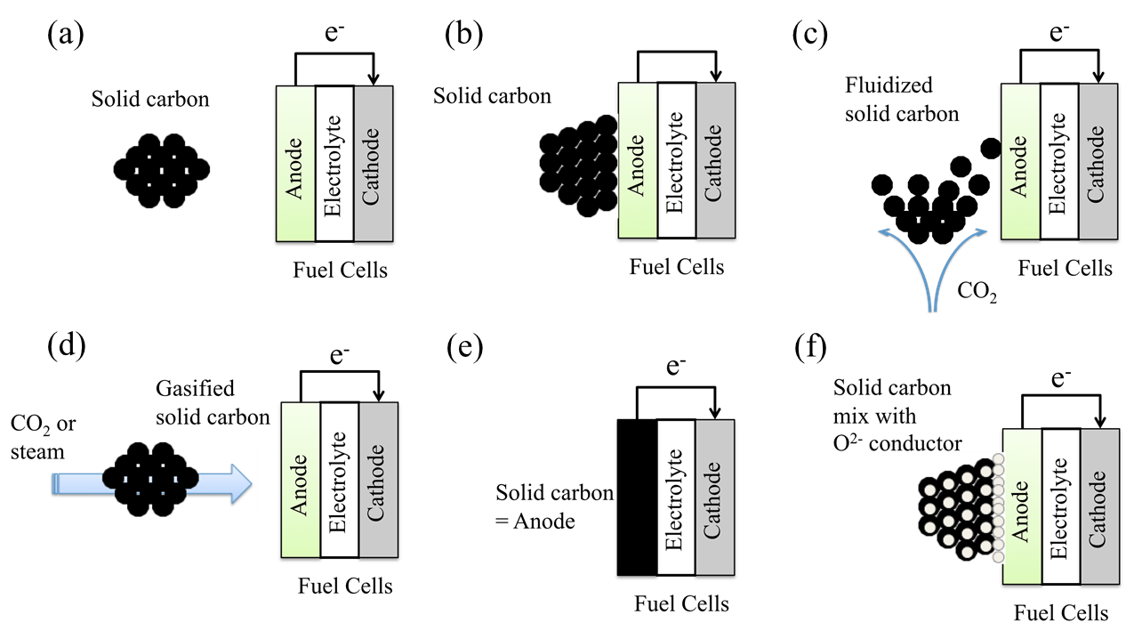

Figure 2. Different contact modes of solid carbon in solid electrolyte based DCFC

Considering that solid carbon is placed in the anode chamber, which is separated by an O²⁻ ionic conductor from the air electrode, the cell potential is established based on the equilibrium of oxygen activity (or partial pressure P_{O2} in ideal case) on two sides such as a concentration cell:

(6)

andare oxygen activity on the cathode and anode, respectively. A noble metal such as platinum (Pt) is pasted on both sides of the ionic conductor as an electrode and a current collector. The half reaction on two sides is written as follows:
on the air electrode (cathode),

(7)

; on the working electrode (anode),

(8)

are oxygen vacancies, andis an oxygen occupied site. In the anode compartment, solid carbon can be oxidized by liberated oxygen to carbon monoxide, which can react with oxygen at three-phase boundary for current generation further.
Form CM03 page_4_ of _13__ pages
(9)

(10)

The cell performance in this scheme largely depends on the oxygen activity on the anode, a_{O2,a}, which is determined by carbon-oxygen equilibrium in the carbon-containing environment.

The placement of solid carbon on the anode and the method for direct oxidation in a physical contact is straightforward. In a contact scheme, the electrochemical oxidation of solid carbon is expected to be:

(11)

Since the contact area between carbon and electrode is limited, solid carbon is less able to extract oxygen from TPB for direct oxidation. The anodic reaction would largely be similar to that in the non-contact scheme. The cell performance would depend on anodic oxygen activity, which is in equilibrium with oxidation of carbon to CO and subsequent CO electrochemical oxidation (Eqn. 10). Although the performance of DC-SOFC in the contact scheme is subject to anodic oxygen activity, a higher OCV can be obtained in a concentrated fuel environment, i.e. CO. Such atmosphere could easily form by gasification and localize at the anode surface enclosed by carbonaceous fuels. The in situ gasification occurs via reverse Boudouard reaction:

C + CO₂ → 2CO (12)

The kinetics of the reverse Boudouard reaction is fast with a conversion to CO up to 90% at 900 °C. The produced CO then diffuses to TPB for electrochemical oxidation. Thus, the CO and CO₂ proceed in a reaction cycle close to the anode, as illustrated in Figure 3, thereby delivering electric power. The involvement of in situ gasification in DC-SOFCs is an attractive process. For example, a fluidized-bed solid oxide fuel cell (FB-SOFC) presented in Fig.2 gives the advantages of easy fueling and separation of ash left from carbon fuels. In addition, the integrated process has the potential to recycle waste heat from fuel cell for endothermic gasification reaction, thus improving the overall efficiency.

Figure 3: Electrode reactions on a solid electrolyte based DCFC

II-2 Timeliness and Relevance of the Project

This proposal is driven by three related factors:
- The importance of carbon resources, especially biomass, and its processing for use in fuel cell
Form CM03 page_5_ of _13_ pages
- The efficient conversion of waste to energy reclaims a valuable lost resource.
- The importance of efficient electricity production in the continued use of carbon resources in a land-constrained world.

The current electricity production system is mainly based on centralised gigawatt scale production in Taiwan; however, some disadvantages appear: 1) the electrical and global efficiency are limited by the thermodynamic Rankine cycle, 2) the transmission and distribution of the electricity present losses on the grid as well as high costs for operation and maintenance, and 3) this production system is adapted for the use of fossil fuels, which is in lack in the island. In today’s context decentralized electricity production seems to be attractive for local production and creation of jobs, decrease of the pressure on the grid and high opportunity to introduce renewable energy. The direct carbon fuel cell concept offers a very efficient alternative for electricity production to current clean carbon technologies allowing coupling with district heating still, with the possibility of CO₂ sequestration.

Carbon exists in several forms and is available as a feedstock in various degrees of purity. Active carbons can be derived from, for example, waste tyres, following suitable processing. A very attractive method of producing carbon that is CO₂ neutral is through pyrolysis of organic materials. Carbon could also be sourced from pyrolytic processing of waste materials (e.g. wood from forest clearance, paper, plastics), enabling consumption of these stockpiles. Moreover, carbon is available from farming of special crops. Use of solid carbon as a fuel would certainly improve energy density over hydrogen.

We propose the development of this very important new technology, direct carbon fuel cell, which could be utilised to complement large scale sequestered clean coal or biomass derived carbon systems. Carbon fuel cells offer very high efficiency of conversion and if implemented in decentralised, MW scale systems can yield 2-3 times the amount of energy for a given amount of carbon. We can successfully apply this technology and generate immense benefit to the global environment and indeed to Taiwan industry.

II-3 Anticipated Problems and Means of Resolution

Oxidation of a solid fuel is a much more difficult process than that of a gaseous fuel such as hydrogen. Both molten carbonate and solid electrolyte based DCFCs face different challenges and difficulties for improving power densities and achieving stable power generation. For molten carbonate based DCFCs, concentration polarization (i.e. fuel or oxidant diffusion) and current collection are major issues. Therefore, ultra-fine carbon particles and effective-contact metal mesh current collector are needed [6]. For solid electrolyte-based DCFCs, the contact of carbon fuel with electrode and interface of electrode/electrolyte, so called three phase boundary (TPB), are limited as shown in Figure 4, and the diffusion of oxidant ions in solid ceramic electrolyte is temperature dependent. Thus, most of research are directed to in situ carbon gasification to generate electricity in a direct DCFC [7-9] (Here, “direct“ does not mean one elementary step reaction ,but instead indicate a direct conversion in one process which can include gasification and fuel cell reactions in one chamber).

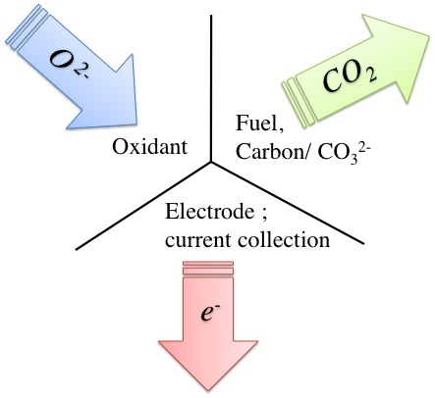

Figure 4. Different contact modes of solid carbon in solid electrolyte based DCFC
Form CM03 page_6_ of _13_ pages
Our approach is to merge solid oxide and molten carbonate fuel cell technologies, using a solid oxide electrolyte to separate the cathode and anode compartments, while a molten carbonate electrolyte is utilised to extend the anode/electrolyte region as shown in Figure 5. Oxygen is reduced to O²⁻ ions at the cathode and transported across the solid electrolyte membrane to the anode compartment, where carbon is oxidised to CO₂. Molten carbonate could enhance the carbon oxidation in two ways as a fuel carrier or as an electrochemical mediator. Enhancement of the anode reaction by the molten carbonate as an electrochemical mediator is also expected:

C + 2CO₃²⁻ → 3CO₂ + 4e⁻ (3)

C + CO₃²⁻ → CO + CO₂+ 2e⁻ (4)

These reactions should be followed by the regeneration of CO₃²⁻ ions in order that the electric charge of the molten carbonate can be kept neutral (Figure 6).

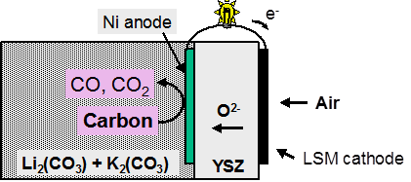

Figure 5. Schematic of a solid electrolyte based DCFC with molten carbonate inside the anode chamber

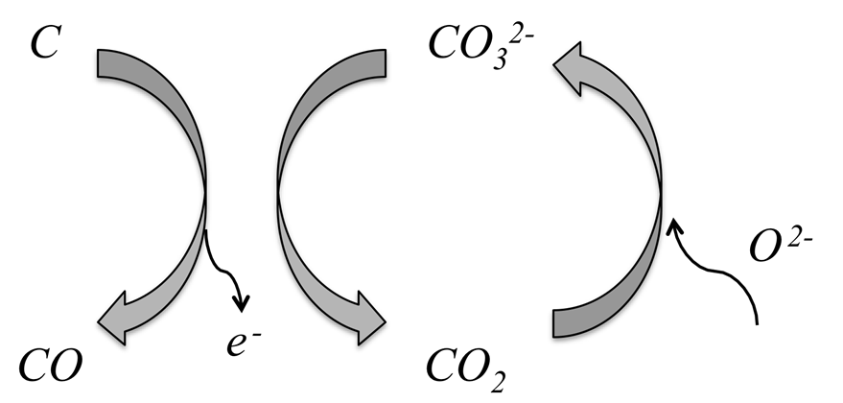

Figure. 2 Carbonate as a mediator for carbon oxidation in a DCFC

This concept avoids the need for CO₂ circulation and protects the cathode from molten carbonate, and allows the use of materials already developed for SOFC applications. Our previous research has demonstrated this concept feasible using a wide range of carbons and carbon-rich fuels such as coal, plastics, carbon colloids, activated carbons and charcoals (Table 2) [2, 20-21]. The carbon/carbonate slurry increased the active reaction zone from a two-dimensional Ni/YSZ anode to a three-dimensional slurry and significantly enhanced carbon oxidation. The electrochemical oxidation in the anode compartment is quite selective to CO₂ formation, but the final distribution of products is dominated by the equilibrium of the Boudouard reaction, which increasingly yields CO as temperature increases. Moreover, fundamentals governing reaction mechanism in DCFC are not well understood. Such limited information can attribute to complexities of three-phase reaction (Solid: carbon, gas: carbon dioxide, liquid: molten salt) in DCFCs compared with two-phase reaction (Gas and solid) in hydrogen fuel cells, and non-standardized fuel from different carbon sources.

Form CM03 page_7_ of _13_ pages
In this regard, these challenges and opportunities motivate us to carry out a series and complete study, aiming at establishing a DCFC protocol in Taiwan and employing it all over the world. Herein we seek to embark upon a programme to address the underlying scientific challenges in the development of 1-10 kW scale combined heat and power carbon fuel cell systems utilising biomass and waste derived carbons.

Table 2 Summary of cell performance for all carbon fuel

(Ref: Andrew C. Chien et. al., Journal of Electrochemical Society, 161 (5) F1-F6 (2014))

II-4 Support for Use of Major Instrumentation

- Pyrolysis Reactor
Preparation of solid carbon fuel from biomass
- Infrared Spectroscopy
Characterization of functional group of solid fuel and eluting gases during pyrolysis
- Adsorption Analyzer
Measurement of surface area and pore size distribution on solid fuel

- Potentiostat
Test of voltage-current relationship and impedance spectra of the cell
- Mass Spectroscopy
Monitoring of effluent gas species from pyrolysis reactor and fuel cell testing chamber
- Die Pressing
Preparation of bottom cell
- Tape Casting Machine
Fabrication of large size fuel cell
- Fuel Cell Testing System/ Jig
Load a fuel cell and construct current collection

Form CM03 page_8_ of _13_ pages
- Anticipated Results and Achievements

III-1. Anticipated Research Tasks

The work plan for this proposal is divided into six primary work packages focusing on core tasks, with sub-tasks listed below:

Task | Work Plan | Quarter
Task | Work Plan | 01 | 02 | 03 | 04 | 05 | 06 | 07 | 08 | 09 | 10 | 11 | 12
A | Biomass Processing and Carbon Fuels Evaluation
B | Carbon Fuel Cell Fabrication and Testing System Setup
C | Carbon Fuel Cell Testing and Cell Material Optimization
D | Thermodynamics and Kinetics Investigation ; Effect of Reactants, Products, Temperature, and others
E | Current Collection Materials and System Design ; Durability Testing
F | System Characterisation and Process Integration

- Biomass Processing and Carbon Fuels Evaluation
This work seeks to take biomass and waste derived charcoals to produce suitable carbon fuel for DCFCs. Processes to produce carbon will be evaluated and optimised to yield the best fuel cell performance. Key parameters to be evaluated are:
- particle size, crystallinity, porosity and morphology
- degree of pyrolysis, including residual aromaticity
- nature and content of impurities
Figure below presents an example of carbon fuel source and its properties from our previous results with European research partner: Instituto Nacional del Carbon (CSIC) Apartado 73, 33080 Oviedo, Spain.

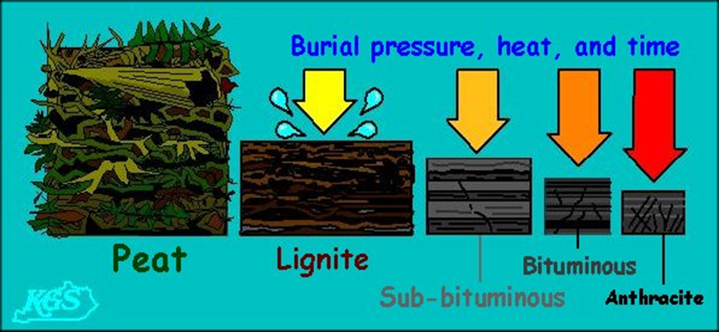

Figure. 7 Type of carbon fuel and their composition
Form CM03 page_9_ of _13_ pages
- Carbon Fuel Cell Development

We are proposing to implement the hybrid SOFC/MCFC geometry for carbon oxidation that we have recently developed as a significant technology as shown in Figure 8. Initial efforts have yielded power densities of greater than 100 mWcm⁻², open circuit voltages > 1 volt, and complete fuel utilisation in various tests. Here we wish to:

- Consolidate these findings and optimise processes for performance and durability.
- Push the electrical performance considerably higher (previous work has been largely limited to the particular geometries with high thermal shock resistance, not traditionally viewed as offering good power density)
Most work will focus on electrolyte, extended (oxide/carbonate) anode and anode current collection as cathode technology can be imported from SOFC. Key tasks are as follows:
- Optimisation of thin zirconia electrolytes for DCFC operation. This involves fabrication of thin zirconia electrolytes by tape casting and slurry coating onto porous substrates
- Application and evaluation of barrier layers to enhance zirconia stability in molten carbonate at open circuit and under operating current.
- Optimisation of composite anode structures for efficient operation
- Modelling and investigating oxidation processes of differing carbons
- Developing durable solutions to anode current collection.

The outputs from this work will be the next generation of DCFC components that will support the electrical performance and durability needed for stationary power. These will have been arrived at ensuring that the solutions are agreeable with respect to manufacturability at the appropriate scale and the requirements of the system.

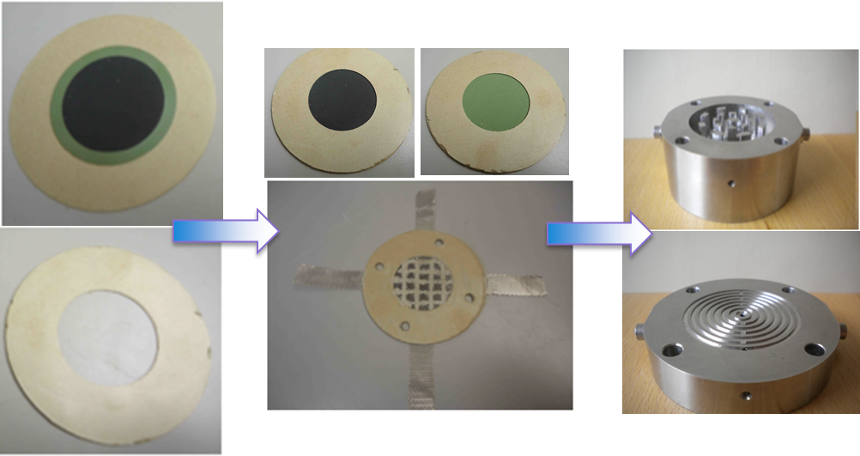

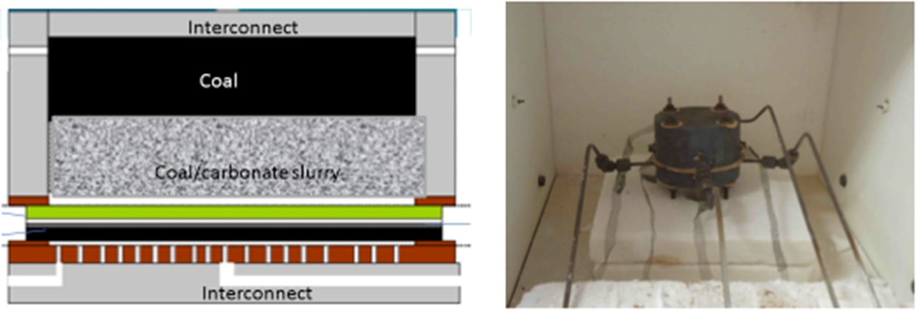

Figure. 8 Assembly of carbon fuel cell and its schematic (Ref: Andrew C. Chien et. Al., Scaling up of the Hybrid Direct Carbon Fuel Cell Technology, International Journal of Hydrogen Energy 38 (2013) 8497-8502)

Form CM03 page_10_ of _13_ pages
- System Design and Durability Testing

Various options need to be considered in designing a DCFC. These are
- best geometry, planar versus tubular
- optimum cell size
- fuel/air distribution arrangements
- thermal management
In this work, we will seek to find best solutions to achieve 1-10 kW scale devices. Thermodynamic modelling will be carried out using standard chemical engineering packages (AspenTech, Simulink etc.), and global system optimisation carried out to enable a scale-up strategy to be developed with respect to the potential applications. For this a preliminary analysis of market opportunities will be carried out, to help define the best concepts to be developed. To enable the best stack configurations to be developed, the influence of different reaction pathways on the overall system thermal performance will be mapped out.

- System Characterisation and Process Integration

In this work results from consideration of system design will be correlated with data from carbon fuel cell development. The resulting information will allow short stacks to be built and evaluated. These tests will in turn inform system design, modelling and cell development actions. Energy that is not converted to electricity will be produced in the form of heat. Here we seek to determine if this heat will be sufficient to utilise in processing of coal or biomass fuels. This depends critically on the dominating electrochemical oxidation process, if direct carbon oxidation to CO₂ dominates then a very high electrical conversion efficiency will result; however, should there be significant less favourable reactions competing then there will be significant waste heat. Possible integrated fuel processing and fuel cell systems will be proposed.

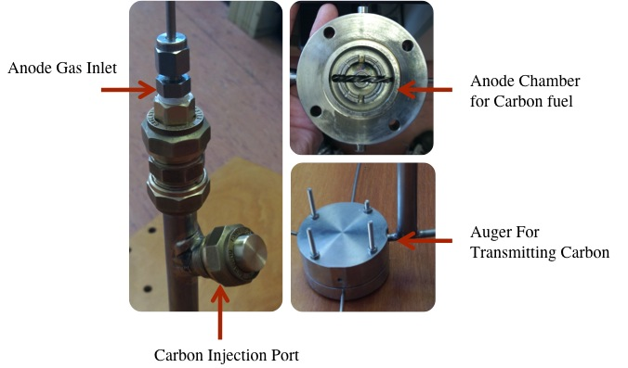

Figure. 9 Design of continuing feeding system

Form CM03 page_11_ of _13__ pages
III-2. Potential Training to Be Gained by Personnel Participating in This Project

This project will support two MS students and one PhD student, probably together with several undergraduate students working on their final year project. They will benefit from this project on i) pretreatment of biomass, catalytic pyrolysis, product separation based on principle of chemical engineering, ii) fabrication of fuel cell, such as ball milling, die pressing, tape casting, and screen printing, state of the art DCFC technology, and electrochemistry, iii) system integration and characterization, including continuous feeding, stack design, and modeling. Other experience of characterization on fuel property and cell performance, i.e. gas adsorption, pore size/ surface area measurement, infrared/Raman spectroscopy, X-ray and photoelectron technique, voltage-current curve and impedance spectroscopy, etc. will be gained too. On the other hand, researcher will be eagerly encouraged to write technical report in English, publish scientific paper in peer reviewed journals, and to attend national/ international conference/symposia. My goal is to equip them with a professional expertise in a global perspective and at the same time to develop them with a social responsibility.

III-3. Anticipated Research Outcomes

We will actively promote the technology and the advances that we make in scientific and technical conferences, such as International of Electrochemical Society, Electrochemical Society (ECS), North America Catalysis Meeting and The European Fuel Cell Forum, addressing not only our academic peers but also the wider renewable and energy technology community who have keen interest in this topic. We except to publish 3-5 peer reviewed papers in three years, discussing our discovery on pre-treatment of carbon fuel, performance of fuel cell, and optimization of cell assembly or design.

III-4. Potential contribution to academics, national developments, or other applications

The objective of this proposal for the contribution to Taiwan are:

- Bring in the state of the art fuel cell technology and share the experience with the government, academia, and industry to develop greed energy

- Build up the research force and team for decentralised electricity generation via DCFC

- To confirm and enhance DCFC performance as being potentially industrially competitive and hence to facilitate development and commercialisation

Form CM03 page_12_ of _13_ pages

REFERENCES

Form CM03 page_13_ of _13_ pages

